EX No:1 | EDA-DATA CLEANING

Aim:
To perform Exploratory Data Analysis (EDA) and data cleaning on the hotel bookings dataset using standard data science frameworks (CRISP-DM, SEMMA, and KDD) by handling missing values, removing duplicates, creating derived features, and analyzing data patterns.

Algorithm:

- Import pandas, numpy, and matplotlib.pyplot.
- Load hotel_bookings.csv and inspect dataset structure, missing values, and duplicates.
- Clean data by removing duplicates, dropping the company column, and imputing missing values in agent, country, and children.
- Convert reservation_status_date to datetime format and engineer new features (total_nights, total_guests).
- Plot frequency distributions for key variables and display a correlation matrix heatmap.
- Summarize business insights and end execution

Program:
import pandas as pd
import numpy as np
import matplotlib.pyplot as plt

# CRISP-DM FRAMEWORK

# ============================================================

# 1. BUSINESS UNDERSTANDING

# Objective:
# Analyze medical appointment patterns,
# patient behavior, no-show trends,
# and factors affecting appointment attendance.

# 2. DATA UNDERSTANDING

df = pd.read_csv("KaggleV2-May-2016.csv")

print(df.head())

print(df.shape)

print(df.info())

print(df.describe())

print(df.isnull().sum())

print(df.duplicated().sum())

# 3. DATA PREPARATION

df.drop_duplicates(inplace=True)

df['Age'] = df['Age'].apply(lambda x: np.nan if x < 0 else x)

df['Age'] = df['Age'].fillna(df['Age'].median())

df['ScheduledDay'] = pd.to_datetime(df['ScheduledDay'])

df['AppointmentDay'] = pd.to_datetime(df['AppointmentDay'])

df['waiting_days'] = (
df['AppointmentDay'].dt.date -
df['ScheduledDay'].dt.date
).apply(lambda x: x.days)

df['appointment_month'] = df['AppointmentDay'].dt.month

df['appointment_day'] = df['AppointmentDay'].dt.day

df['appointment_weekday'] = df['AppointmentDay'].dt.day_name()

df['total_conditions'] = (
df['Hipertension'] +
df['Diabetes'] +
df['Alcoholism']
)

# 4. MODELING (EDA)

df['Gender'].value_counts().plot(kind='bar')

plt.title("Gender Distribution")

plt.show()

df['No-show'].value_counts().plot(kind='bar')

plt.title("Appointment No-Show")

plt.show()

df['Neighbourhood'].value_counts().head(10).plot(kind='bar')

plt.title("Top 10 Neighbourhoods")

plt.show()

df['appointment_weekday'].value_counts().plot(kind='bar')

plt.title("Appointments by Weekday")

plt.show()

df['SMS_received'].value_counts().plot(kind='bar')

plt.title("SMS Received")

plt.show()

corr = df.select_dtypes(include='number').corr()

plt.figure(figsize=(10,8))

plt.imshow(corr)

plt.colorbar()

plt.xticks(
range(len(corr.columns)),
corr.columns,
rotation=90
)

plt.yticks(
range(len(corr.columns)),
corr.columns
)

plt.title("Correlation Heatmap")

plt.show()

# 5. EVALUATION

print("Business insights generated successfully.")

# 6. DEPLOYMENT

print("Insights can be deployed through dashboards.")

# SEMMA FRAMEWORK

# ============================================================

# SAMPLE

df = pd.read_csv("KaggleV2-May-2016.csv")

# EXPLORE

print(df.head())

print(df.info())

print(df.describe())

print(df.isnull().sum())

print(df.duplicated().sum())

# MODIFY

df.drop_duplicates(inplace=True)

df['Age'] = df['Age'].apply(
lambda x: np.nan if x < 0 else x
)

df['Age'] = df['Age'].fillna(
df['Age'].median()
)

df['ScheduledDay'] = pd.to_datetime(
df['ScheduledDay']
)

df['AppointmentDay'] = pd.to_datetime(
df['AppointmentDay']
)

df['waiting_days'] = (
df['AppointmentDay'].dt.date -
df['ScheduledDay'].dt.date
).apply(lambda x: x.days)

df['appointment_month'] = (
df['AppointmentDay'].dt.month
)

df['appointment_day'] = (
df['AppointmentDay'].dt.day
)

df['appointment_weekday'] = (
df['AppointmentDay'].dt.day_name()
)

df['total_conditions'] = (
df['Hipertension'] +
df['Diabetes'] +
df['Alcoholism']
)

# MODEL

df['Gender'].value_counts().plot(kind='bar')

plt.show()

df['No-show'].value_counts().plot(kind='bar')

plt.show()

df['Neighbourhood'].value_counts().head(10).plot(kind='bar')

plt.show()

df['appointment_weekday'].value_counts().plot(kind='bar')

plt.show()

df['SMS_received'].value_counts().plot(kind='bar')

plt.show()

corr = df.select_dtypes(include='number').corr()

plt.figure(figsize=(10,8))

plt.imshow(corr)

plt.colorbar()

plt.xticks(
range(len(corr.columns)),
corr.columns,
rotation=90
)

plt.yticks(
range(len(corr.columns)),
corr.columns
)

plt.show()

# ASSESS

print("Patterns and trends successfully identified.")

# KDD FRAMEWORK

# ============================================================

# SELECTION

df = pd.read_csv("KaggleV2-May-2016.csv")

# PREPROCESSING

print(df.info())

print(df.isnull().sum())

print(df.duplicated().sum())

df.drop_duplicates(inplace=True)

df['Age'] = df['Age'].apply(
lambda x: np.nan if x < 0 else x
)

df['Age'] = df['Age'].fillna(
df['Age'].median()
)

# TRANSFORMATION

df['ScheduledDay'] = pd.to_datetime(
df['ScheduledDay']
)

df['AppointmentDay'] = pd.to_datetime(
df['AppointmentDay']
)

df['waiting_days'] = (
df['AppointmentDay'].dt.date -
df['ScheduledDay'].dt.date
).apply(lambda x: x.days)

df['appointment_month'] = (
df['AppointmentDay'].dt.month
)

df['appointment_day'] = (
df['AppointmentDay'].dt.day
)

df['appointment_weekday'] = (
df['AppointmentDay'].dt.day_name()
)

df['total_conditions'] = (
df['Hipertension'] +
df['Diabetes'] +
df['Alcoholism']
)

# DATA MINING

df['Gender'].value_counts().plot(kind='bar')

plt.show()

df['No-show'].value_counts().plot(kind='bar')

plt.show()

df['Neighbourhood'].value_counts().head(10).plot(kind='bar')

plt.show()

df['appointment_weekday'].value_counts().plot(kind='bar')

plt.show()

df['SMS_received'].value_counts().plot(kind='bar')

plt.show()

corr = df.select_dtypes(include='number').corr()

plt.figure(figsize=(10,8))

plt.imshow(corr)

plt.colorbar()

plt.xticks(
range(len(corr.columns)),
corr.columns,
rotation=90
)

plt.yticks(
range(len(corr.columns)),
corr.columns
)

plt.show()

# INTERPRETATION

print(
"Knowledge discovered from the dataset "
"has been interpreted to support "
"healthcare appointment management decisions."
)
Output:

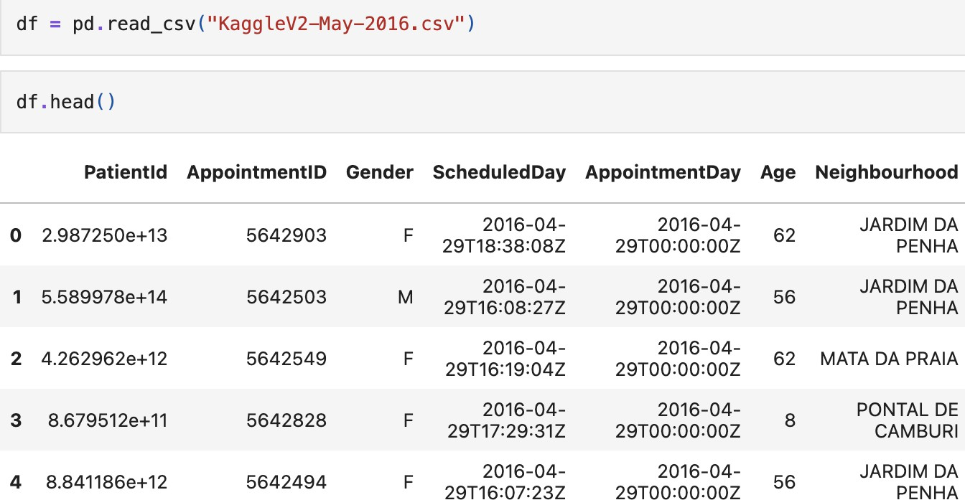

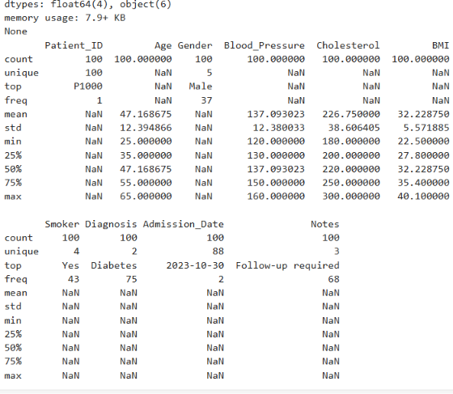

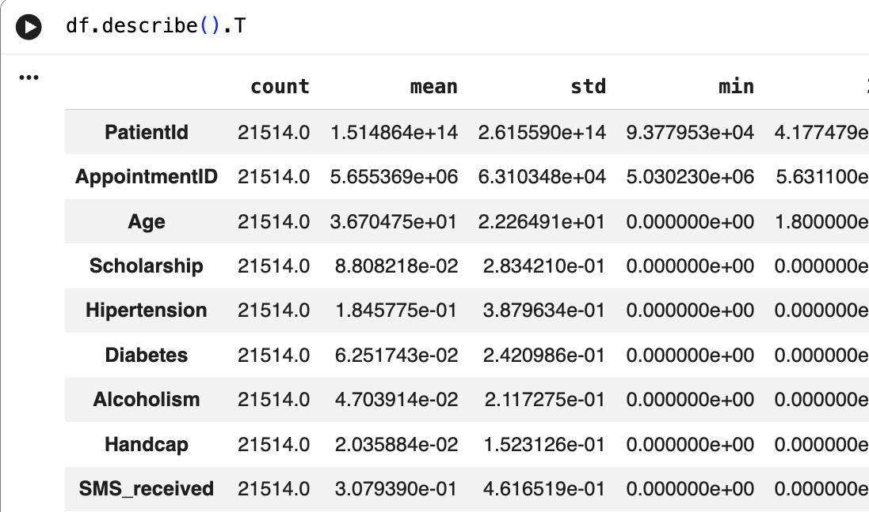
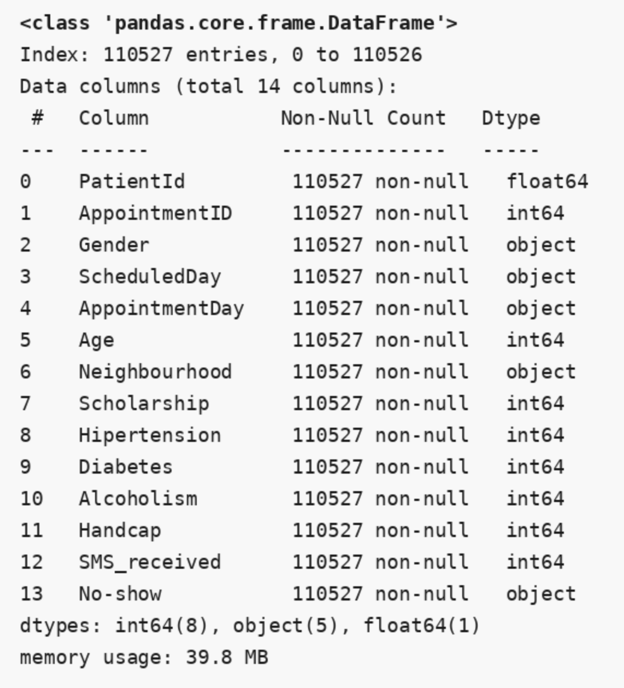
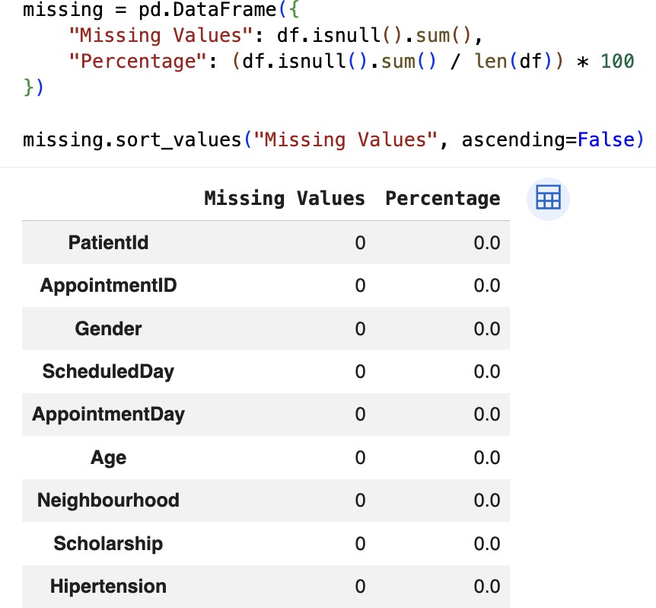
$

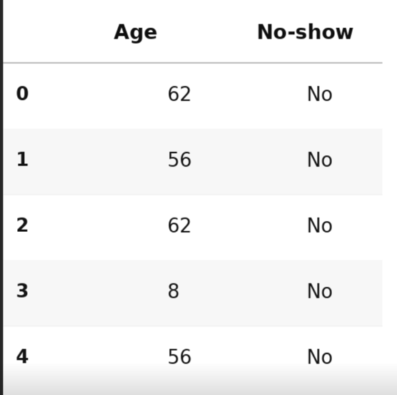

Result:

